**UNIT-4**

**Question Bank**

**1. It is very important to understand the customer’s wants and needs before you begin designing or building a computer-based solution. For the same explain all requirement engineering tasks in details.**

* Requirements engineering focuses on being the **connector** between **modeling, analysis, design, and construction**.
* It is the **process** that **defines, identifies, manages, and develops requirements** in a software engineering design process.
* This process **uses tools, methods, and principles** **to describe the system’s behavior** and the constraints that come along with it.
* Requirements engineering is the most important part every business must follow, in order to build and release a project successfully, as it is the foundation to key planning and implementation.

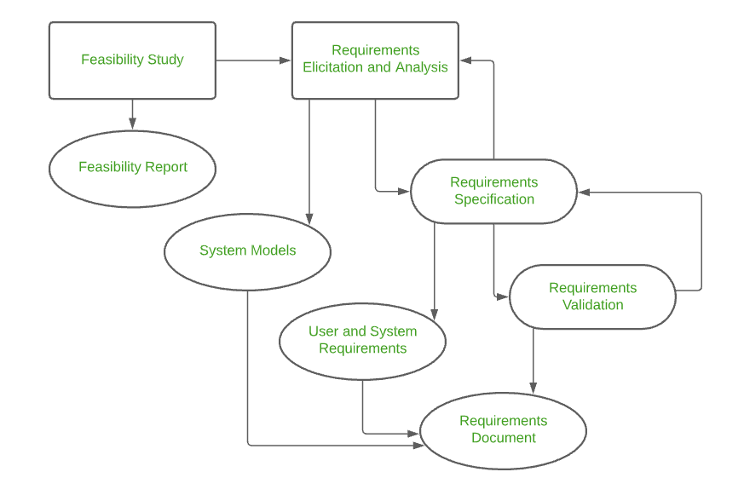

**Requirements Engineering Tasks:**

* Inception
* Elicitation
* Elaboration
* Negotiation
* Specification
* Validation
* Requirements Management

1. **Inception:**

* This is the first phase of the **requirements analysis process**.
* This phase gives an **outline** of how to get started on a project.
* In the inception phase, all the **basic questions** are asked on how to go about a task or the **steps required** to accomplish a task.
* A basic **understanding** of the **problem is gained** and the nature of the **solution** is addressed.
* **Effective communication** is very important in this stage, as this phase is the foundation as to what has to be done further.
* Overall, in the inception phase, the following criteria have to be addressed by the software engineers:
* **Understanding of the problem.**
* **The people who want a solution.**
* **Nature of the solution.**
* **Communication and collaboration between the customer and developer.**

1. **Elicitation:**

This is the second phase of the requirements analysis process.

This phase focuses on **gathering the requirements from the stakeholders**.

Understanding the kind of **requirements needed from the customer** is very **crucial** for a developer.

In this process, **mistakes can happen** in regard to, not implementing the right requirements or forgetting a part.

The **right people** must be involved in this phase.

The following problems can occur in the elicitation phase:

**Problem of Scope:**

* The requirements given are of unnecessary detail, ill-defined, or not possible to implement.

**Problem of Understanding:**

* Not having a clear-cut understanding between the developer and customer when putting out the requirements needed.
* Sometimes the customer might not know what they want or the developer might misunderstand one requirement for another.

**Problem of Volatility:**

* Requirements changing over time can cause difficulty in leading a project. It can lead to loss and wastage of resources and time.

1. **Elaboration:**

* This is the third phase of the requirements analysis process.
* This phase is the result of the inception and elicitation phase.
* It takes the requirements that have been stated and gathered in the first two phases and refines them.
* The main task in this phase is to indulge in modelling activities and develop a prototype that elaborates on the features and constraints using the necessary tools and functions.

1. **Negotiation:**

* This is the fourth phase of the requirements analysis process.
* This phase emphasizes discussion and exchanging conversation on what is needed and what is to be eliminated.
* In the negotiation phase, negotiation is between the developer and the customer and they dwell on how to go about the project with limited business resources.
* Risks of all the requirements are taken into consideration and negotiated in a way where the customer and developer are both satisfied with the further implementation.
* The following are discussed in the negotiation phase:
* **Availability of Resources.**
* **Delivery Time.**
* **Scope of requirements.**
* **Project Cost.**
* **Estimations on development.**

1. **Specification:**
   * This is the fifth phase of the requirements analysis process.
   * This phase specifies the following:

* **Written document.**
* **A set of models.**
* **A collection of use cases.**
* **A prototype.**

In the specification phase, the requirements engineer gathers all the requirements and develops a working model.

This final working product will be the basis of any functions, features or constraints to be observed.

The models used in this phase include

* ER (Entity Relationship) diagrams,
* DFD (Data Flow Diagram),
* FDD (Function Decomposition Diagrams),
* Data Dictionaries.

A software specification document is submitted to the customer in a language that he/she will understand.

1. **Validation:**

* This is the sixth phase of the requirements analysis process.
* This phase focuses on checking for errors and debugging.
* In the validation phase, the developer scans the specification document and checks for the following:
* **All the requirements have been stated and met correctly**
* **Errors have been debugged and corrected.**
* **Work product is built according to the standards.**
* This requirements validation mechanism is known as the formal technical review.
* The review team that works together and validates the requirements include software engineers, customers, users, and other stakeholders.
* Everyone in this team takes part in checking the specification by examining for any errors, missing information, or anything that has to be added or checking for any unrealistic and problematic errors.
* Some of the validation techniques are the following-
* **Requirements reviews/inspections.**
* **Prototyping.**
* **Test-case generation.**
* **Automated consistency analysis.**

1. **Requirements Management:**

* This is the last phase of the requirements analysis process.
* Requirements management is a set of activities where the entire team takes part in identifying, controlling, tracking, and establishing the requirements for the successful and smooth implementation of the project.
* In this phase, the team is responsible for managing any changes that may occur during the project.
* New requirements emerge, and it is in this phase, responsibility should be taken to manage and prioritize as to where its position is in the project and how this new change will affect the overall system, and how to address and deal with the change.
* Based on this phase, the working model will be analysed carefully and ready to be delivered to the customer.

**2. If a team want to develop a “Customer Address Book” using the Waterfall methodology and you are the part of this team, the order of work would be as follows. Product manager creates Use-cases document that include the following Use-cases:**

**• User can login to the system.**

**• User should be able to create new contacts.**

**• User should be able to view their contacts.**

**• User should be able to import contacts from other programs.**

**• User should be able to email their contacts from the address book.**

**• User should be able to add pictures to represent their contacts.**

**• There is one admin who can manage all these things.**

**Note: This system must have valid login. Help manager to draw the diagram of overall system that shows Users view with all the elements.**

**3. Why SRS is document also known as black box specification of a system? What are the contents of SRS?**

SRS document is a contract among the development team and the customer. Once the SRS document is accepted by the customer, any subsequent controversies are settled by referring the SRS document.

The SRS document is called as black-box specification. Since the system is considered as a black box whose internal details are not known and only its visible external (i.e., input/output) behavior is recognized.

* Introduction
* Purpose.
* Intended Audience.
* Intended Use.
* Scope.
* Definitions and Acronyms.
* Overall Description.
* User Needs.
* Assumptions and Dependencies.
* System Features and Requirements.

**4. The library management system should be able to handle the requests for membership, issue and return of books as well as handle the purchase of books from the suppliers. Draw the context diagram for library management system.**

**5. Explain any two requirement elicitation methods.**

**Requirements elicitation Methods:**

* Interviews
* Brainstorming Sessions
* Facilitated Application Specification Technique (FAST)
* Quality Function Deployment (QFD)
* Use Case Approach

**1. Interviews:**

* Objective of conducting an interview is to understand the customer’s expectations from the software.
* It is impossible to interview every stakeholder hence representatives from groups are selected based on their expertise and credibility.
* Interviews maybe be open-ended or structured.
* Context free questions may be asked to understand the problem.
* In structured interview, agenda of fairly open questions is prepared.
* Sometimes a proper questionnaire is designed for the interview.

**2. Brainstorming Sessions:**

* It is a group technique
* It is intended to generate lots of new ideas hence providing a platform to share views.
* A highly trained facilitator is required to handle group bias and group conflicts.
* Every idea is documented so that everyone can see it.
* Finally, a document is prepared which consists of the list of requirements and their priority if possible.

**6. List the characteristics of good SRS?**

* Completeness
* Clarity
* Correctness
* Consistency
* Verifiability
* Ranking
* Modifiability
* Traceability
* Feasibility

**7. Draw the SRS template.**

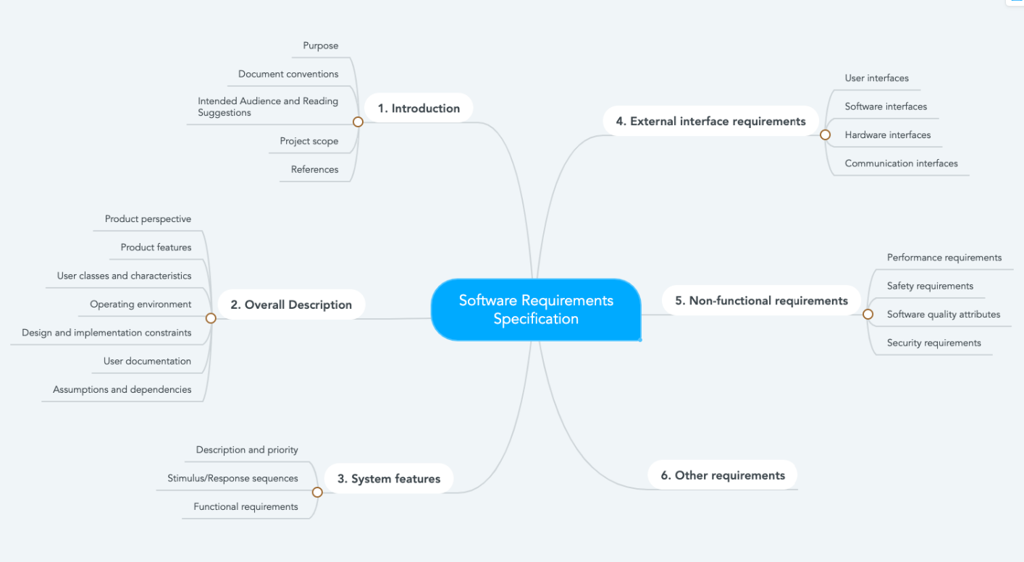

**8. Define “requirement engineering”. How does the domain knowledge help in requirement analysis? What are the underlying principles that guide analysis work? Why is it difficult to gain a clear understanding of what the customer wants?**

**Requirement Engineering** is the process of defining, documenting and maintaining the requirements. It is a process of gathering and defining service provided by the system.

Requirements Engineering Process consists of the following main activities:

* Requirements elicitation
* Requirements specification
* Requirements verification and validation
* Requirements management

**Q.** **How does the domain knowledge help in requirement analysis?**

* The results indicate that domain knowledge clearly affects the elicitation process and the way the analysts conduct the elicitation.
* The findings provide insights as to both positive and negative effects of domain knowledge on requirements elicitation, as perceived by participants with and without domain knowledge.

**Q. What are the underlying principles that guide analysis work?**

**Principles that Guide Process:**

* Be agile
* Focus on quality at every step
* Be ready to adapt
* Build an effective team
* Establish mechanisms for communication and coordination
* Manage change
* Assess risk
* Create work products that provide value for others

**Principles that guide practice:**

* Divide and conquer
* Understand the use of abstraction
* Strive for consistency
* Focus on the transfer of information
* Build software that exhibits effective modularity
* Look for patterns

**9. Develop an ER diagram for library management system.**

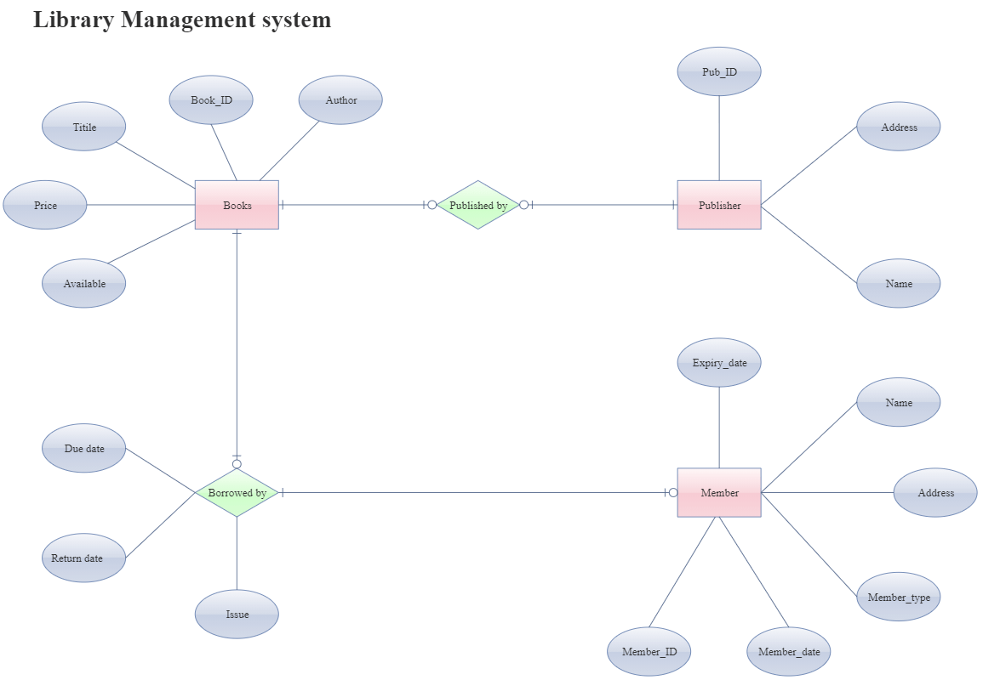

**10. Draw UML diagrams (use case, activity and sequence) for online ticket booking system for IPL 2020 tournament.**